Gulf Capital - ADMAF Creativity Award 2020
LITERATURE CATEGORY

CALL FOR APPLICATIONS

Deadline: 30 January 2020

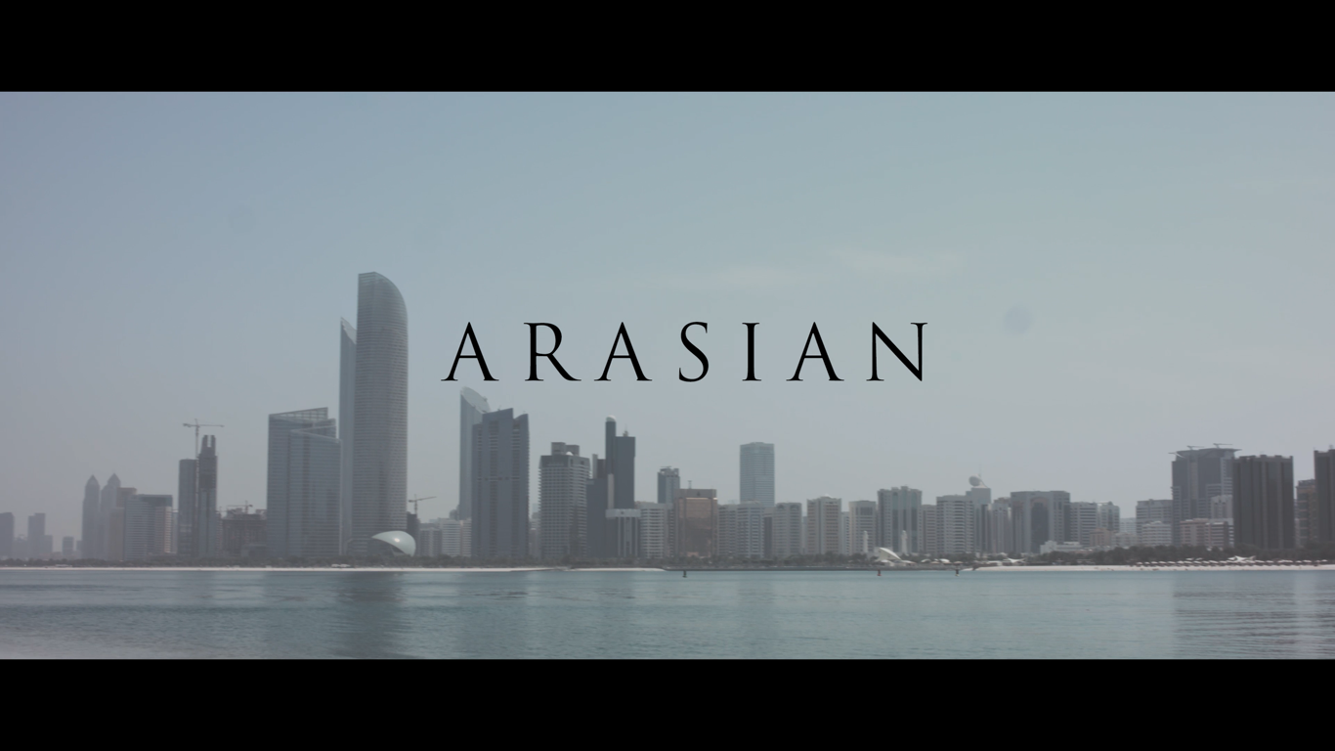

2018 Award Winner Ahmed Al Tunaiji for his short film “Arasian”

About ADMAF
The Abu Dhabi Music & Arts Foundation (ADMAF) seeks to nurture the arts, education, culture and creativity for the benefit of society and the advancement of Abu Dhabi’s cultural vision. Established in 1996 by H.E. Hoda Al Khamis-Kanoo, the Foundation is a not-for-profit organisation under the presidency and patronage of H.E. Sheikh Nahayan Mabarak Al Nahayan, Minister of Tolerance. ADMAF delivers year-round arts education and community arts initiatives as well as special projects and the Abu Dhabi Festival. It brings together audiences of all ages and nationalities, and nurtures the creativity of the UAE in partnership with national & international institutions.

About ADMAF Creativity Award
The Award was established in 1996 to celebrate outstanding young national creativity in the visual and performing arts, literature and film.
The 2020 version of the Award, however, will only accept applications in the Literature category. The genres are Poetry, Drama, Prose, Nonfiction, Media

Admission and selection criteria
- Entries are welcome from Emirati nationals aged between 18 and 35 years.
- Each application must be supported by a nominator.
- Group applications are accepted of up to 2 members (with 1 Emirati member)
- The submission should not be more than 3 years old.
- Nominator and applicant are requested to submit a completed application form together with a completed work in the category of literature.
- A jury selects the winner. They will be looking for the following attributes in the entries:
- Artistic Merit
- Evidence of original and creative thinking
- Personal application of technical skills

Winner(s)
- The winner will receive a cash prize of AED 10,000
- The winner will attend the Award ceremony which may take place during the Abu Dhabi Festival in March/April, 2020
- The winning work may be displayed in one of the Abu Dhabi Festival venues in March/April 2020

How to enter
- Fill the Application form below. Form can also be downloaded at www.admaf.org
- Entries should be sent by email to education@admaf.org
- Shortlisted applicants will be notified by end of February 2020
- Shortlisted applicants will be invited to present their work accompanied by their nominators by mid/end February 2020
- The winner will be notified by early March, 2020

Terms & Conditions
- The competition is free to enter
- A nominator may submit up to three nominations
- Entries may be submitted in Arabic or English
- Only completed entries will be accepted and submissions will not be returned
- The applicant of the nominated entry confirms that he/she has not been paid for their work
- Neither students nor nominators will receive payment for their entries
- In entering the Award, applicant warrants that their entry is completely original under his/her own creation, all content therein is accurate and lawful, and does not contain material that is harmful, libelous or defamatory to, or material that may infringe the right of, any person or entity in any nature. The applicant will be obliged to indemnify any damage ADMAF may suffer as a result of any inconsistency to the foregoing
- Applicants will retain ownership of copyright for their entry. After submission to the competition, ADMAF has the right to use the nominated work in connection with the competition. ADMAF has the right to copy, display, publish and make available all nominated work in any format (whether online or in print or otherwise) in connection with the competition
- There is one winner and the jury’s decision is final
- The nominator will facilitate the winning applicant’s attendance and participation in the Award Ceremony during Abu Dhabi Festival 2020
- The winner agrees to appear in all photography and film associated with ADMAF Creativity Award and will be requested to sign a waiver accordingly
- The winner agrees to join the ADMAF Alumni and contribute to the promotion of future editions of ADMAF Creativity Award
- The winner must claim the prize within 12 months of receipt
- The applicant’s contact details will be added to the ADMAF database in order to receive future updates from the Foundation

Previous winners of The ADMAF Creativity Award include:

2019, Shamma Faisal Al Bastaki, New York University, Poetry
2018 Ahmed Al Tunaiji, screenwriter and director, New York University, for his short film ‘Arasian’
2017 Afra Atiq, poet, PhD candidate of UAE University, for the poem ‘Open Letter to Cancer’.
2016 Jumaanah El Hashemi, undergraduate (graphic design), Zayed University College of Arts and Creative Enterprises for the typeface ‘Degree’.
2015 Ayesha Al Badi, graduate (visual arts), Zayed University College of Arts and Creative Enterprises for the oil on canvas portrait ‘M9108’.
2014 Fatma Fairooz, undergraduate (visual arts), Zayed University College of Arts and Creative Enterprises for the oil on canvas portrait ‘Katharina’.
2013 Hamda Rubaya Khamis Busamah, undergraduate (visual arts), Zayed University College of Arts and Creative Enterprises for a powerful, site-specific sculpture evoking memory and exploring the roles girls play within the family unit.
2012 Hasan Murad Al Beloushi, Mona Ahmed Alhammoudi, Khawlah Khalfan Ali Al Neaimy, Ranim Ibrahim Albloushi, Asma Rashid Saif Al Shamsi, Fatoum Saeed Ahmed Al Shikh, Haya Ali Abdulla Ali Mohamed Bin Younes Al Tenaiji, Huda Mohammed Salim Mohammed Rashid Al Qaydi, Tamadhar Ahmed Amer Al Rawas and Zainab Ahmed Ali Hassan Al Baloushi of UAE University Al Ain for attending the Young Media Leaders or the City University New York Creative Arts Summer Course.
2010 26 Applied Media Department and Interior Design students from Higher Colleges of Technology (Abu Dhabi Women’s College) for ‘The Desert Rose’ exhibition and ‘Bourdonnard’ children’s opera (Afra Mumtaz Ahmed Ali, Alya Ateeq Obaid Thani Al Romaithi, Ayesha Ahmed Hasan Mohamed Al Tajir Al Tenaji,Ayesha Ahmed Mohamed Al Dhaheri, Ayesha Eisa Sultan Eisa Al Hameli, Ghadeer Ali Mohammed Ali Abdulla Al Mastaka, Mona Khalfan Abdulla Ahmed Abdulla Al Muhairbi, Naeema Obaid Mohamed Binraba Alktebi and Shamma Ahmed Abdulla Bin Saleem Al Teneiji)
2009 Faisal Al Saari, Saoud Al Mulla, Majed Al Marzouqi and Naif Al Mansoori from Higher Colleges of Technology (Abu Dhabi Men’s College) for the ‘Story of A Nation’ documentary

TURN TO THE NEXT PAGE TO COMPLETE THE APPLICATION FORM

APPLICATION FORM

TO BE COMPLETED BY THE NOMINATOR
Name
Title
Institution
Telephone
Email
Postal address
TO BE COMPLETED BY THE APPLICANT
Name
Date of birth
Nationality
Mobile number
Email
Postal Address
University
Course of Study & Year

PROJECT TITLE AND TECHNICAL SPECIFICATIONS
Please give details of your work including (if applicable):
1) Title
2) technique used & process
3) length / duration

APPLICANT’S BIOGRAPHY and STATEMENT
Please give us an overview of your growth, mentioning your major achievements and sharing dreams and ambitions regarding your future career.

Then summarize your entry, focusing on the reasons that brought you to conceive and create the work, on the meaning/message behind it and on the role that the work plays in your development. (max. 500 words)

NOMINATOR’S STATEMENT – Endorsement of Entry
Please describe the work and explain your motivation and rationale for nominating it.
(max. 300 words)

SUPPLEMENTARY MATERIALS ADMAF welcomes the submission of supplementary information of the entry or of other similar work made by the applicant in order to better understand the applicant’s style and commitment.
Please list below the materials you will attach to this form, if any.

I agree to the terms and conditions of the ADMAF Creativity Award

Nominator’s signature
Applicant’s signature

Date ________________________

